**Create the App Catalog site collection**

The first step is to create the App Catalog site collection if it hasn't already been created.

1. Go to SharePoint Admin Center
   1. <https://[tenant]-admin.sharepoint.com>
2. SharePoint Framework solutions are deployed to an app catalog when they are ready for distribution
3. Under **Apps**, select **Open**

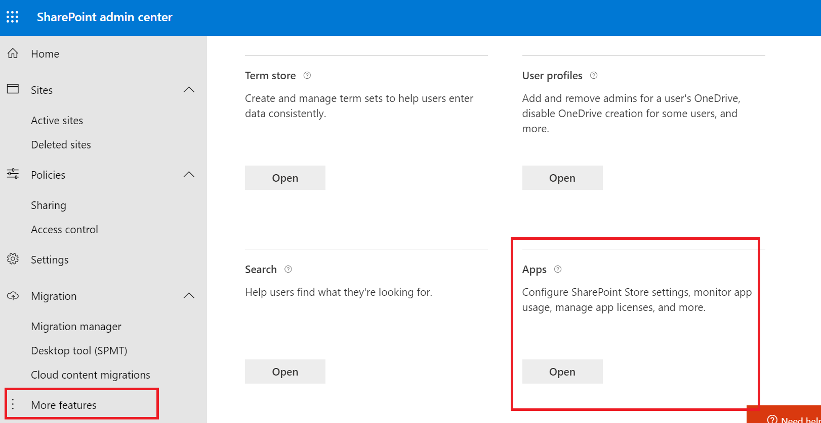

1. Select **App Catalog**.
2. If the **App Catalog** site doesn't open, select **Create a new app catalog site**, and then select OK.
3. App catalog site dialog with Automatically create a new app Catalog site take up to 1 minute selected.

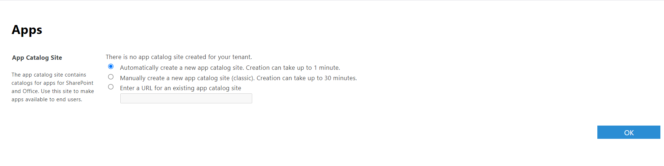

It will create a app CatLog

<https://spfxvodafone.sharepoint.com/sites/appcatalog/SitePages/Home.aspx>

